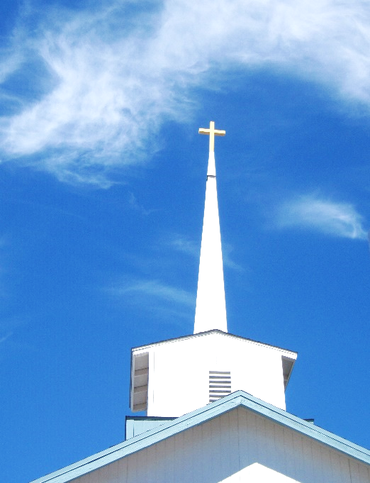
FBC Family Bible Hour
SUMMER 2021 / 8:30 AM

Class Subject: Ecclesiology 801 - The Church.

This theological study on the Doctrine 0f the Church is called the Doctrine of Ecclesiology, coming from the Greek word, “ecclesia” meaning a gathering or an assembly of like-minded believers. As our society becomes more secularized the church must become more sanctified. Our nation and communities, our families and our society are only as strong and morally pure as the church. There is no more essential study than how we as a church must function and remain faithful until Christ returns to this earth. The one institution that God has ordained, next to the family is the Church. Marriage and the family are under relentless attack today by secular humanists and those bent on a one world government. Jesus said, ‘He would build His Church and that the gates of hell would not prevail against it.’

LESSON ELEVEN: Church History – (313-1453) A.D.
The Seven General Periods of Church History:
1. The APOSTOLIC Church 30-100 A.D.
- Part One: The Pentecostal Church
- Part Two: The Expanding Church
- Part Three: The Church Among the Gentiles
- Part Four: The Age of Shadows
2. The PERSECUTED Church. 100-313 A.D.
- Part One: The Imperial Persecutions
- Part Two: Formation of the New Testament Canon / Growth of Ecclesiastical Organizations / Development of Doctrine
- Part Three: The Rise of Sects and Heresies
3. The ___________________________ Church. 313-476 A.D.
4. The ___________________________ Church. 476-1453 A.D.
5. The ___________________________ Church. 1453-1648 A.D.
6. The ___________________________ Church. 1648-1970 A.D.
7. The ___________________________ Church. 1970-Present
________________________________________________________________________________________________
Hymn #479 Onward Christian Soldiers

3. The IMPERIAL Church. 313-476 A.D.
- In thinking of our own cultural challenges today what potential positive and negative results might come from a great spiritual and even political victory? (See: ‘The Coming Revival’ by Bill Bright, New Life Publications, Orlando, Florida © 1995) Chapter Five: Revival Fires.

- How did Emperor Constantine change the political climate for Christians and Christianity? (H.58,59)
The Good Results to the Church:
1.) ___________________________ ended. (H.59)
2.) ___________________________ restored.
3.) ___________________________ Sacrifices ceased. (H.60)
4.) ___________________________ Consecrated.
5.) ___________________________ of Churches.
6.) ___________________________ of the Clergy.
7.) ___________________________ of Sunday.
The Good Results to the State:
1.) ______________________________ abolished. (H.61)
2.) ______________________________ repressed.
3.) ______________________________ modified.
4.) ______________________________ games suppressed.
3. The Bad and Evil Results of Christian Victory:
1.) ______________________________ in the church. (H.62)
2.) ______________________________ usages.
3.) ______________________________ church.
4.) ______________________________ united with the state.

4. What were the controversies and councils in this time period?
1.) ______________________________ controversy. (H.67)
2.) ______________________________ controversy.
3.) _______________________________ controversy.
5. How did the rise of Monasticism influence Christianity?
1.) It’s Origin: (H.69)
2.) It’s Founder:
3.) Pillar Saints:
4.) Growing power of the Roman Catholic Church: (H.70-71)

4. The MEDIEVAL CHURCH: (476 – 1453)
- The Pope: The Vicar of Jesus Christ:

- Causes of Papal Power: (H.83-85)

- The Rise of Mohammed and Islam: (H.89-91)

- The Crusades: (1095-1291) (H.99)
- The First Crusade: (1095-1099) – Peter the Hermit. (H.100)

- The Second Crusade: (1147-1192)

- The Third Crusade: (1188-1192) The King’s Crusade. (H.101)

- The Fourth Crusade: (1201-1204)

- The Fifth Crusade: (1212) The Children’s Crusade

- The Sixth Crusade: (1228-1229)

- The Seventh Crusade: (1248-1254)

- The Eighth Crusade: (1270-1272) (H.102)

- The Causes of Failure in the Crusades:

- Some Good Results of the Crusades: (H.102-104)

- Some Benefits of Monasticism: (H.106-107)

- Some Evil Results of Monasticism: (H.107-108)

- Beginning of Religious Reforms: (H.110-114)
- The Albigenses: Puritans.

- The Waldensians:
- John Wycliffe: (1329-1384)

- John Huss: (1369-1415)

10. Great Scholars and Leaders during the Medieval Church:
- Anselm:
- Abelard:
- Bernard of Clairvaux:
- Thomas Aquinas:
11. What’s the Big takeaway from these two great eras of Church History?

