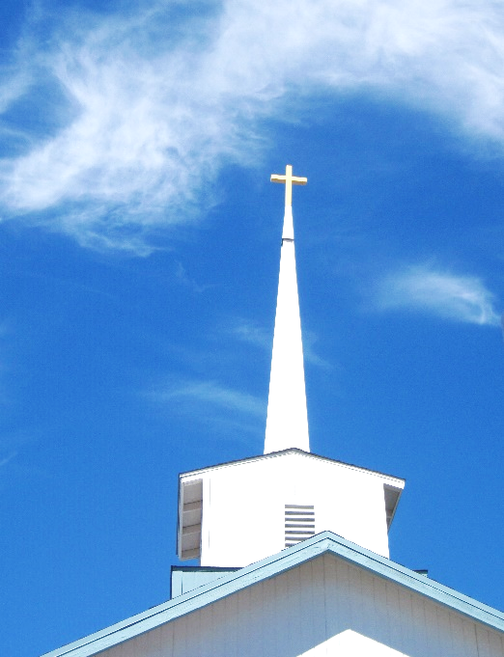
FBC Family Bible Hour
SUMMER 2020 / 8:30 AM

Class Subject: Ecclesiology 801 - The Church.

This theological study on the Doctrine 0f the Church is called the Doctrine of Ecclesiology, coming from the Greek word, “ecclesia” meaning a gathering or an assembly of like-minded believers. As our society becomes more secularized the church must become more sanctified. Our nation and communities, our families and our society are only as strong and morally pure as the church. There is no more essential study than how we as a church must function and remain faithful until Christ returns to this earth. The one institution that God has ordained, next to the family is the Church. Marriage and the family are under relentless attack today by secular humanists and those bent on a one world government. Jesus said, ‘He would build His Church and that the gates of hell would not prevail against it.’

LESSON EIGHT: Church History – Week One: 30 A.D. – 100 A.D.
The Seven General Periods of Church History:
1. The ___________________________ Church 30-100 A.D.
- Part One: The Pentecostal Church
- Part Two: The Expanding Church
- Part Three: The Church Among the Gentiles
- Part Four: The Age of Shadows
2. The ___________________________ Church. 100-313 A.D.
- Part One: The Imperial Persecutions
- Part Two: Formation of the New Testament Canon / Growth of Ecclesiastical Organizations / Development of Doctrine
- Part Three: The Rise of Sects and Heresies
3. The ___________________________ Church. 313-476 A.D.
- Part One: The Victory of Christianity
- Part Two: The Founding of Constantinople / Division of the Empire / Suppression of Heathenism / Controversies and Councils / Rise of Monasticism
- Part Three: The Roman Church Grows in Power / Downfall of the Roman Empire / Leaders of the Period
4. The ___________________________ Church. 476-1453 A.D.
- Part One: Progressive Power of Papal Authority
- Part Two: The Rise of Mohammed and Islam
- Part Three: The Holy Roman Empire / Separation of Latin and Greek Churches
- Part Four: The Crusades
- Part Five: Development of Monasticism / Medieval Art and Literature
- Part Six: The Beginning of Religious Reform / The Fall of Constantinople / Scholars and Leaders
5. The ___________________________ Church. 1453-1648 A.D.
- Part One: Antecedent Forces / The German Reformation
- Part Two: The Reformation in other lands / Principles of Reformation
- Part Three: The Counter-Reformation / Leaders of the Period
6. The ___________________________ Church. 1648-1970 A.D.
- Part One: The Puritans
- Part Two: The Wesleyans
- Part Three: The Rationalists
- Part Four: The Anglo-Catholic Movement
7. The ___________________________ Church. 1970-Present
- The Modern Missionary Movement
- The Church in the Twentieth Century
- The Church in the Twenty First Century
- Christian Churches in the United States
__________________________________________________________________________________________________
1. The Pentecostal Church. From the Ascension of Jesus Christ (30 A.D.) to the Preaching of Stephen (35 A.D.) Part One: The Pentecostal Church.
- The Definition of the Church:

- The Beginning of the Church:

Mark 16:20

Acts 1:6-8

- The Endowment of the Church:

Acts 1:15

Acts 2:1-4

I Corinthians 3:16

I Corinthians 12:13

Ephesians 2:21,22

- The Locality of the Church:

- The Membership of the Church:
HEBREWS:
Acts 6:1
Acts 21:40
HELLENISTS:
Acts 2:9-11
Acts 6:9
PROSELYTES:
Acts 6:5
- The Leaders of the Church:

- The Government of the Church:

- The Doctrine of the Church:

1.) Jesus is the Messiah:

2.) Jesus is the Resurrected LORD:

3.) Jesus is Coming Again.

- The Gospel Testimony of the Church:
Acts 2:4,11,17,18
- The Miracles in the Church:
Acts 3:1-8
Acts 5:1-11
Acts 5:12-16
Acts 6:8
- The Spirit of Oneness and Brotherhood in the Church:
Acts 2:44,45, 32-37
Community Property:
1.) Voluntary
2.) Small Community
3.) Select People
4.) Christ’s Imminent Return
5.) Financial Need: Acts 11:29, Romans 15:25,26
6.) Moral Failures
- The Church’s One Defect: Acts 1:8
2. The Expanding Church. From the Preaching of Stephen (35 A.D.) to the Council of Jerusalem. Part Two: The Expanding Church.
- From A.D. 35 – 50 we see settled the great question of _____________________________________.
- Stages of Expansion:

1.) Stephen’s _________________________________.

Acts 6:1-5; Acts 6:11-14; Acts 7:2-53; Acts 7:57-60

2.) Saul’s _____________________________________.

Acts 7:58; Acts 22:3; Acts 8:3,4; Acts 26:9-11; Acts 26:9-11

3.) Philip in ___________________________________.

Acts 6:5; 8:5-13; 8:14-17; 8:40
4.) Peter at Joppa and Caesarea.

Acts 9:32-43; 10:9-16; 17-48

5.) Saul’s _____________________________________.

Acts 9:1-22

6.) The Church at ______________________________.

Acts 11:19-30; I Peter 4:16

7.) The First Missionary Journey. Acts 13:14:

8.) The Council at Jerusalem. Acts 15:

3. The Church Among the Gentiles. From the Council of Jerusalem (AD 48) to the Martyrdom of St. Paul. (AD 68) Part Three: The Church Among the Gentiles. (50-68 A.D.)
1.) The Church Authorities:
2.) The Field of the Church:
3.) The Missionary Journeys of Paul:
- Second Missionary Journey – Acts 15:36-18:22
- Third Missionary Journey – Acts 18:23-21:17
- Fourth Missionary Journey – Acts 27:-28:
4.) First Imperial Persecution: (A.D. 65-68)
5.) Martyrdom of St. Paul. (A.D. 68)
6.) Literature of the Period.
4. The Age of Shadows. From the Martyrdom of St. Paul. (AD 68) to the Death of St. John. (AD 100) Part Four: The Age of Shadows. (68-100 A.D.)
1.) The Fall of Jerusalem. (70 A.D.)
Matthew 24:
2.) The Second Imperial Persecution. (90-96 A.D.)

3.) The Completion of the New Testament.

4.) The Condition of the Church:
- Extent and Numbers
- Doctrine
- Institutions
- Easter / Resurrection Sunday
- Church Officers
- Worship
- Spirituality
LESSONS TO BE LEARNED AT FAMILY BIBLE CHURCH FROM THE HISTORICAL RECORD OF THE PENTECOSTAL CHURCH:

