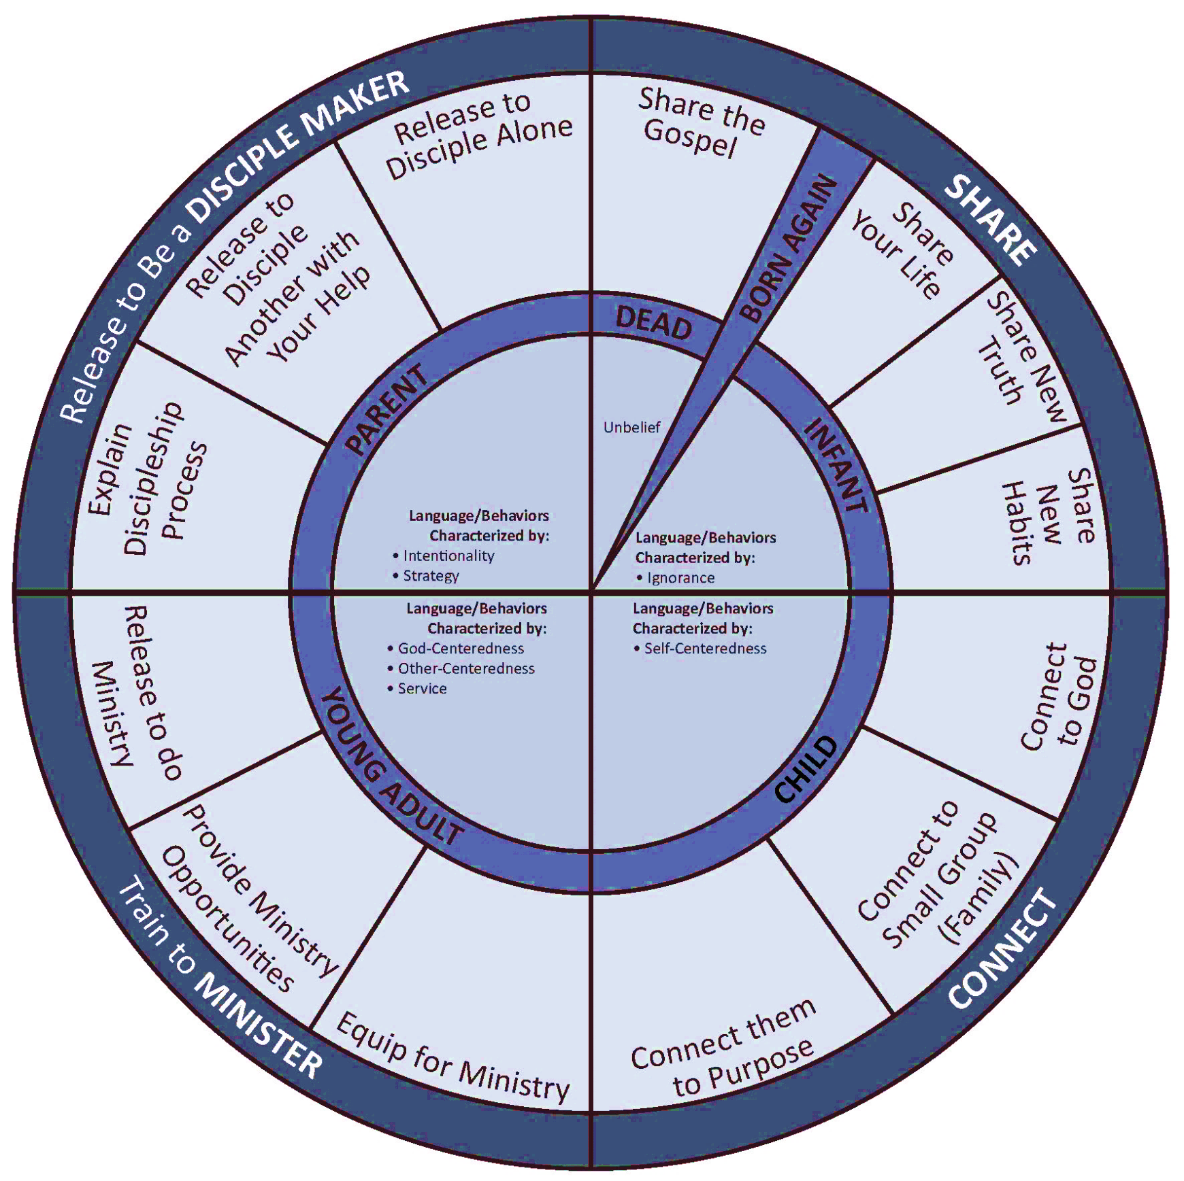
The Five Stages of Discipleship
From DiscipleSHIFT by: Putman, Harrington and Coleman
Zondervan Books, c. 2013
Used With Permission

